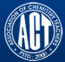 Association of Chemistry Teachers (ACT)
C/o. Homi Bhabha Center for Science Education (HBCSE), TIFR, Mumbai-400 088

News Letter Issue-6/September- December, 2016
Geometry & Symmetry in Indian Architecture: Rameswaram Temple, TAMIL NADU – 12th Century Temple built in Dravidian Architecture – 4000 pillars line across the corridor
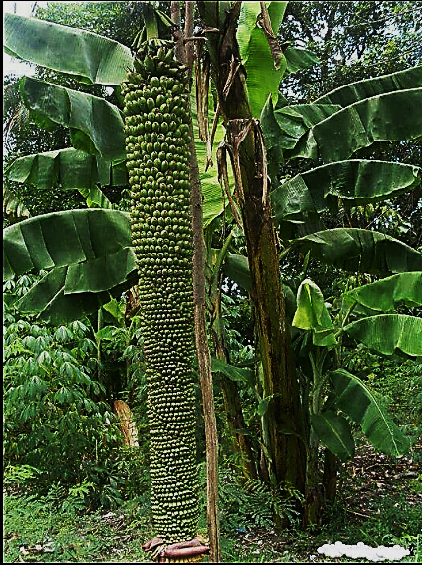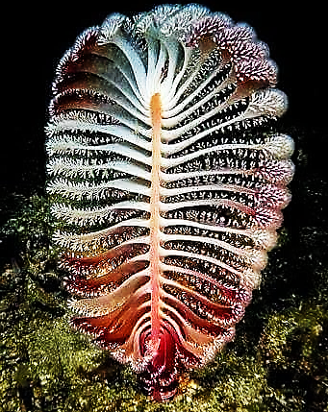

From the Editor’s Desk
Wishing in advance the entire fraternity of ACT, a Merry Christmas; a very happy, healthy and prosperous New Year. The present Editorial Board has put in its bit of efforts, to make the newsletter as attractive and informative as possible. We tried to direct the attention of our readers towards advanced research trends taking place across the globe so as to motivate them to take up initiative in re-orienting themselves towards advanced topics of research and teaching methods.

I strongly feel that, the future research should pay adequate attention to multidisciplinary nature of science; and collaborative research towards effective utilization of the available instrumental resources at various academic institutions and research establishments across the country. In this direction, ACT has a vital role to play in assisting financially towards meeting testing charges for researchers in the rural sector across the country.

I take this opportunity to say many, many thanks to all my editorial board
Members for their whole hearted co-operation extended to me. I have requested the new Executive – Council to re-constitute the Editorial Board suitably so as to give representation from all the corners of the country and to give more technical and scientific impetus to this volume.

With warm regards to one and all
Dr. M. R. R. PRASAD

New Executive Council of ACT (2017 – 2019)
President: Prof (Dr.) D C Deka, Gauhati University, Guwahati
General Secretary: Dr. D V Prabhu, Wilson College, Mumbai
Treasurer: Mrs. Swapna Narvekar, HBCSE (TIFR), Mumbai

North Zone:
Vice-President: Prof. M. S. M. Rawat, Doon University, Dehradun, Uttarakhand.
Secretary: Prof. Shraddha Sinha, B. B. Das National Institute of Technology and Management, Lucknow, U. P.
EC – Members: Dr. Umesh Chandra Jain, Principal, DPS, Bharatpur.
Dr. Amar Srivastava, D. A. V. (PG) College, Kanpur, U. P.
Co-opted member: Mr. Shailendra Jain, Shaivi Industries, Lucknow, U. P.
North-East Zone:
Vice-President: Prof. Dileep Kumar Kalita, Tinsukia, Assam.
Secretary: Dr. Nripendra Nath Talukdar, Pub - Kamrup, Assam.
EC – Members: Dr. Hari Sankar Kakati, DK College, P. O. Mirza, District Kamrup, Assam.
Dr. Md. Abdul Halim Shah, D. M. College of Science, Imphal, Manipur

Eastern Zone:
Vice-President: Prof. Prem Mohan Mishra, MLSM College, Darbhanga, Bihar.
Secretary: Dr. Subhash Prasad Singh, A. N. College, Patna, Bihar.
EC – Member: Dr. Jayasree Laha, Principal, Raja N. L. Khan Women’s College, Midnapore, west Bengal.
Western Zone:
Vice-President: Dr. Hemant Pande, Hislop College, Nagpur.
Secretary: Dr. Meera Uchil, Wilson College, Mumbai.
EC – Members: Prof. (Dr.) Anand S. Aswar, HOD-Chemistry, Sant
Gadge Baba Amravati University, Amravati,
Maharashtra
Dr. Shahin D. Irani, Wilson College, Mumbai
Co-opted Member: Dr. W. B. Gurnule, Kamala Nehru Mahavidyalaya,
Nagpur.
Central Zone:
Vice-President: Prof. Brijesh Pare, Jawaharlal Nehru PG College,
Ujjain, M. P.
Secretary: Prof. V. P. Singh, Regional Institute of Education,
Ajmer, Rajasthan.
EC-Members: Dr. Dheeraj Mandloi, Institute of Engineering &
Technology, Devi Ahilya University, Indore, MP
Dr. Surabhi Benjamin, Pacific College of Basic and
Applied Sciences, PAHER University, Udaipur,
Rajasthan
Southern Zone:
Vice-President: Dr. P. V. S. Machiraju, Pragati Engineering College,
Surampalem, Andhra Pradesh
Secretary: Prof. (Dr.) Helen Kavitha, SRM University,
Ramapuram campus, Chennai, Tamil Nadu
EC – Members: Prof. K. Sudhakarbabu, Sri Krishnadevaraya
University, Anantapuram, Andhra Pradesh
Dr. Mannam Krishnamurthy, Varsity Education
Management Limited, Hyderabad, Telangana.
Co-opted Member: Prof. (Dr.) M. Swaminathan, Emeritus Professor,
Kalasalingam University, Krishnan Koil, Tamil Nadu
Past Presidents:
- Prof N Sathyamurthy, Director ,IISER Mohali
- Prof S R Gadre, Emeritus Professor ,University of Pune, Pune
- Prof PK Sai Prakash, Osmania University, Hyderabad
- Prof Sudha Jain, Lucknow University
- Prof S D Samant, ICT, Mumbai
===========================================================================
Achievements & Awards:
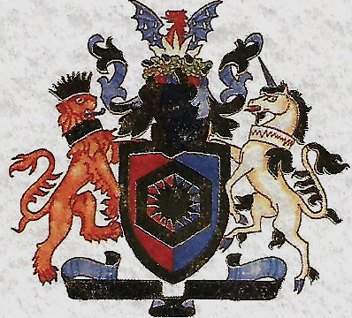 Prof. Meenakshisundaram Swaminathan, FRSC has been admitted as the Fellow of the Royal Society of Chemistry on 08 July, 2016.
During the National Convention of Chemistry Teachers (NCCT-2016) held on October 21 – 23, 2016, at Raja N. L. A. Khan Women’s College (Autonomous), Midnapore, West Bengal - Prof. (Dr.) Prashant Singh, DAV (PG) College, Dehra Dun was bestowed with Shri Anupam Sinha - Best Chemistry Teacher Award; Prof. (Dr.) Chitrani Medhi, University of Guwahati was bestowed with ACT Best Woman Chemistry Teacher Award; Prof. (Dr.) Hemant Pande, Hislop College, Nagpur was bestowed with Dr. Uma Sai Prakash Chemistry Popularization Award; Prof. (Dr.) Suresh Reddy, Sri Venkateswara University, Tirupati was bestowed with Prof. Lallan Singh – Best PG Chemistry Teacher award; Prof. (Dr.) Kshiradhar Baruah, Biswanath College, Chariali, Assam was bestowed with Prof. P. R. Singh – Outstanding Contribution to Chemistry Education Award. ACT heartily congratulates each one of the award winners for their valuable contributions.
International Junior Science Olympiad (IJSO) was held on December 02, 2016 at Bali, Indonesia. The Indian Team has won the first place along with Taiwanese Team among the participants from 48 countries. Mr. Archit Boobna, Ayushman Tripathy, Nishant Abhangi, Rajdeep Singh Dhingra, and Gaurang Dev have won Gold medals; and Anandavardhan Goli captured the Silver Medal. The delegation leaders include – Prof. (Dr.) D. V. Prabhu, Wilson College, Mumbai; Prof. (Dr.) Pradeep Kumar Burma, University of Delhi; and Dr. A. K. Rajaranjan of Bhabha Atomic Research Centre (BARC), Mumbai, Kudos to the entire team for bringing laurels to India and more so to ACT.

Dynamism of ACT during September – December, 2016:
- Concept Test in Chemistry for undergraduate students (CONTECH – 2016) nationally coordinated by Prof. (Dr.) Subhash Prasad Singh, A. N. College, Patna was held on September 24, 2016.
- National Convention of Chemistry Teachers (NCCT 2016) along with National Symposium on "Chemistry and Environment (CE-2016),” was held during October 21 – 23, 2016 at Raja N. L. A. Khan Women’s College (Autonomous), Midnapore, West Bengal.
- National Standard Examination in Chemistry (NSEC-2016) was held on November 27, 2016 at over 1350 centers across the country.
- ACT – News Letter covering the period January – April, 2016 has been published on the ACT – Website.
- Dr. M. R. R. Prasad gave a Keynote Address at the International Seminar on “Recent Trends in Chemical sciences – Global Perspective and Progress,” held at SGG College, Banswara, Rajasthan, during November 28-29, 2016.
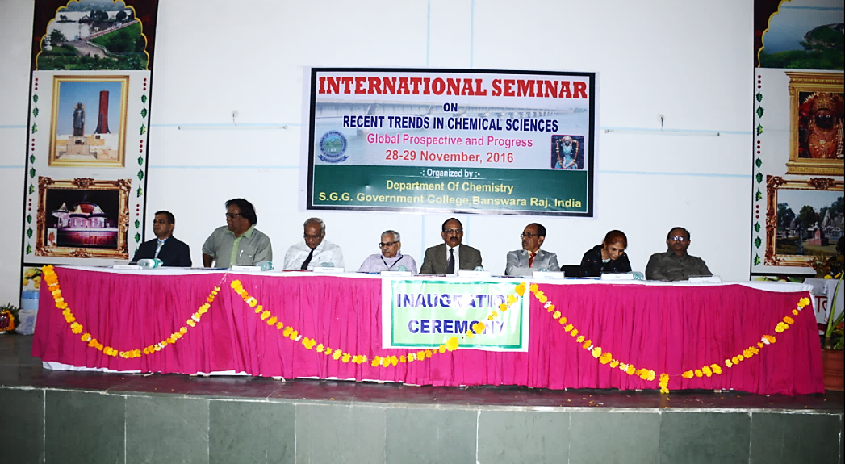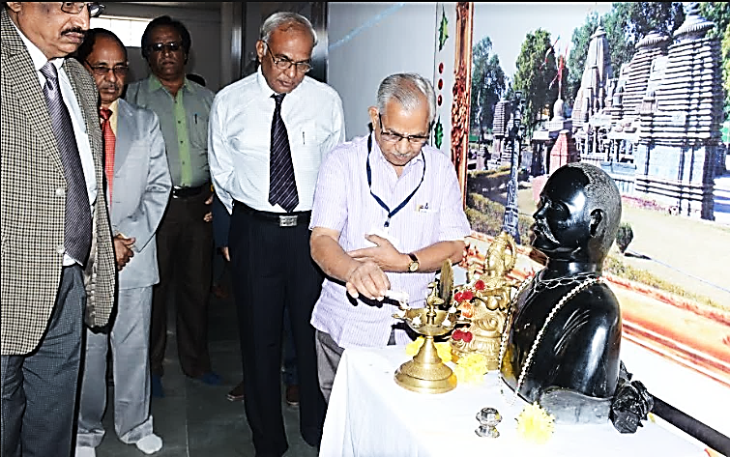
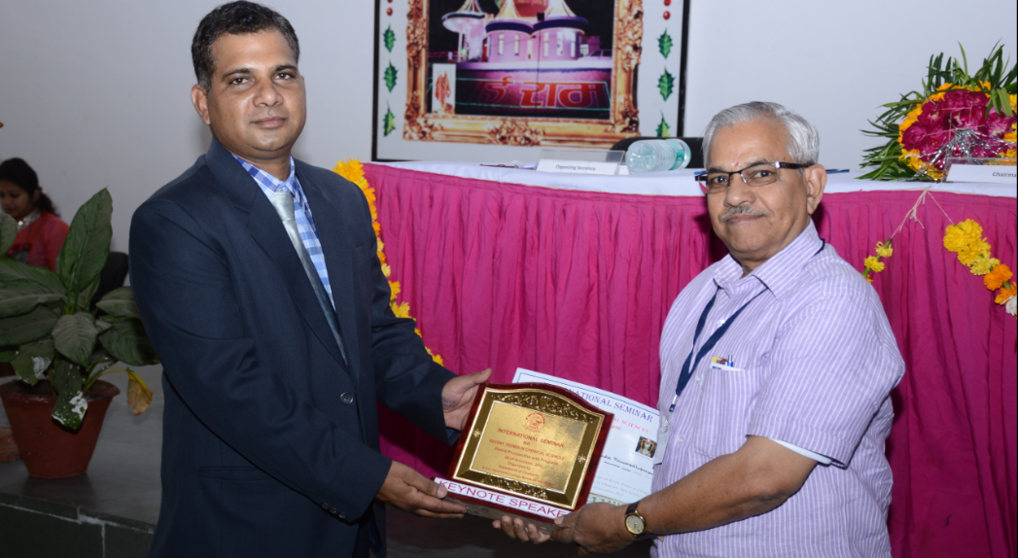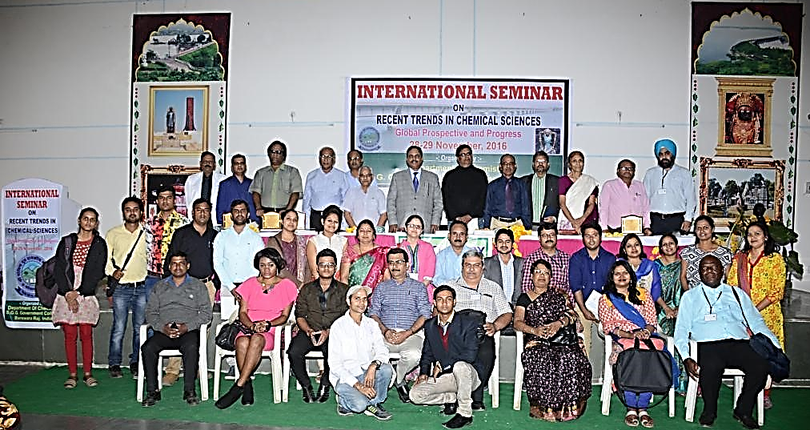
- National Chemistry Day Celebrations-2016 was conducted by the Department of Chemistry, P. R. Government College (Autonomous), Kakinada in Association with ACT, Mumbai. Dr. Kumara Swamy, Senior Scientist from IICT, Hyderabad was invited as Chief Guest. Dr. Chappidi Krishna, Principal chaired the program.
- National Chemistry Day-2016 was celebrated on 10.12.2016 at the Department of Chemistry, SRM University, Ramapuram, Chennai, in association with ACT. Written Quiz, Essay and Drawing competitions were held in ASSISI Matriculation School. Around 400 students participated in various competitions. Prizes were given to all the winners and participation certificates were distributed to all the participants.
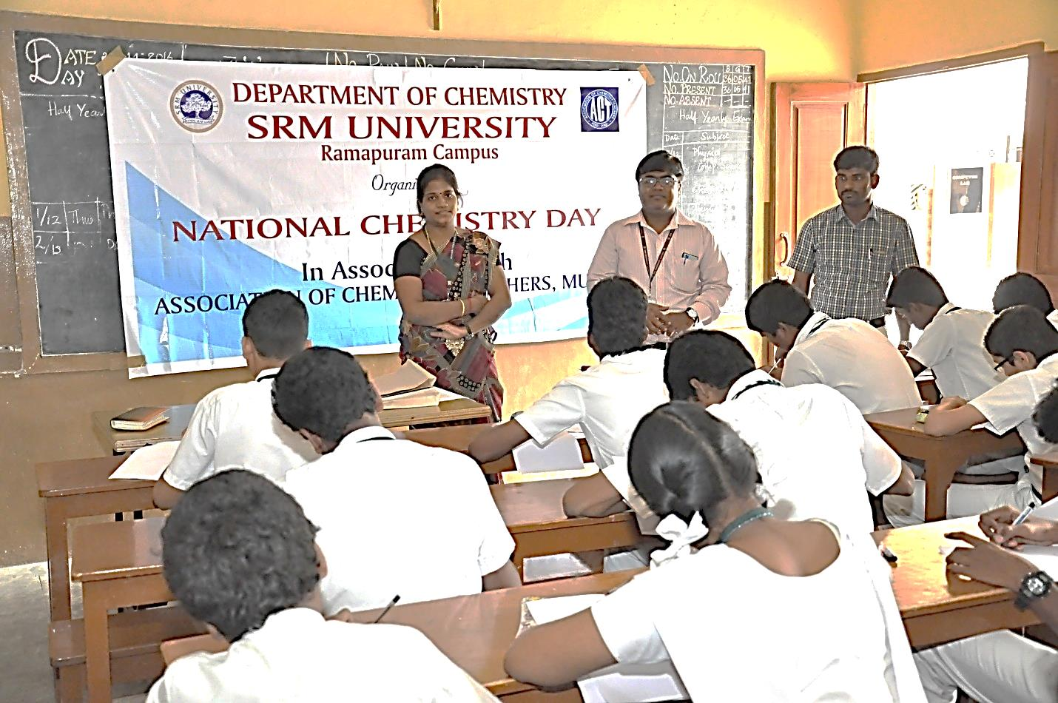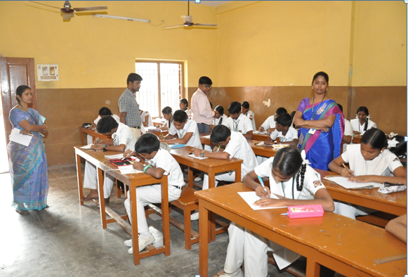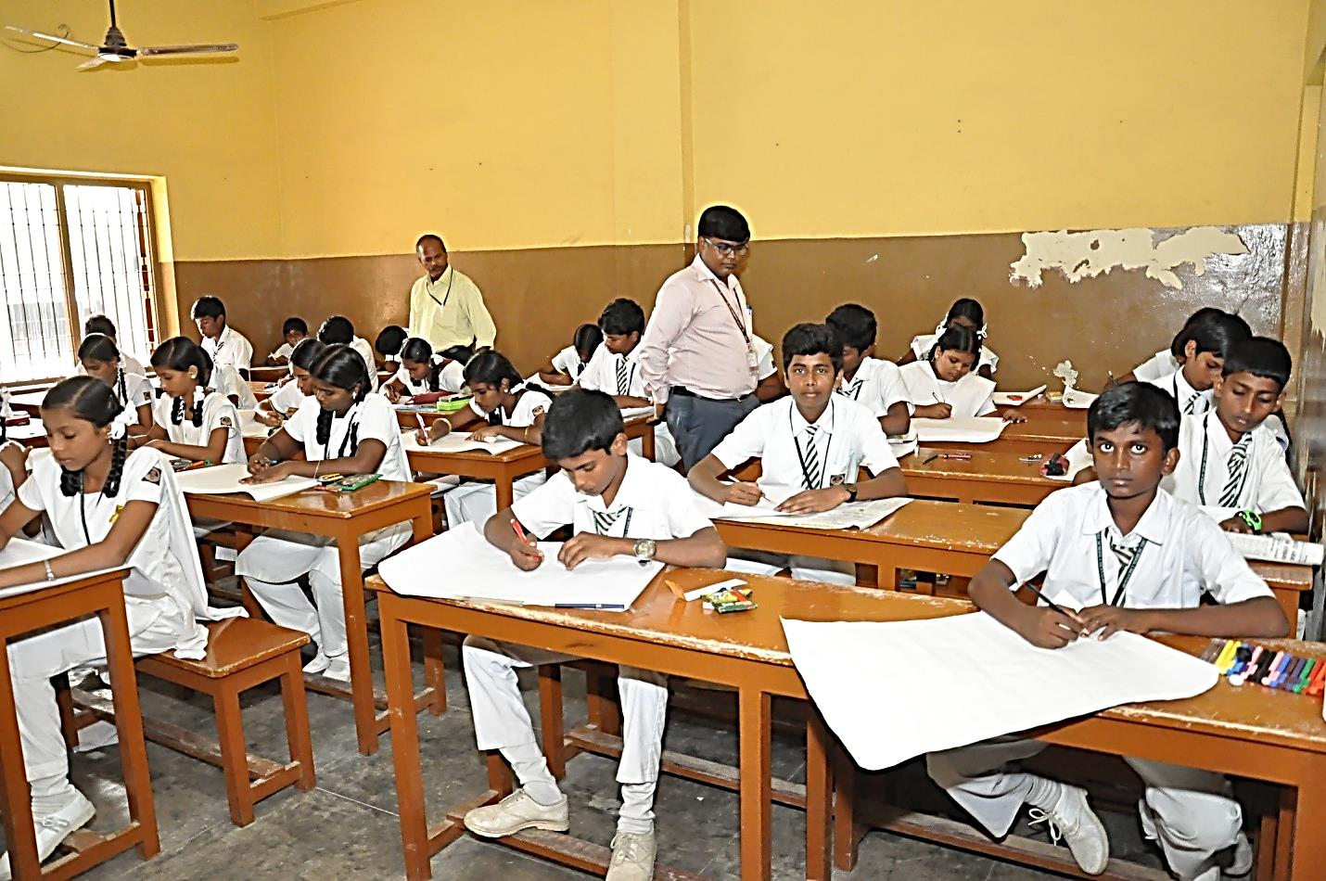
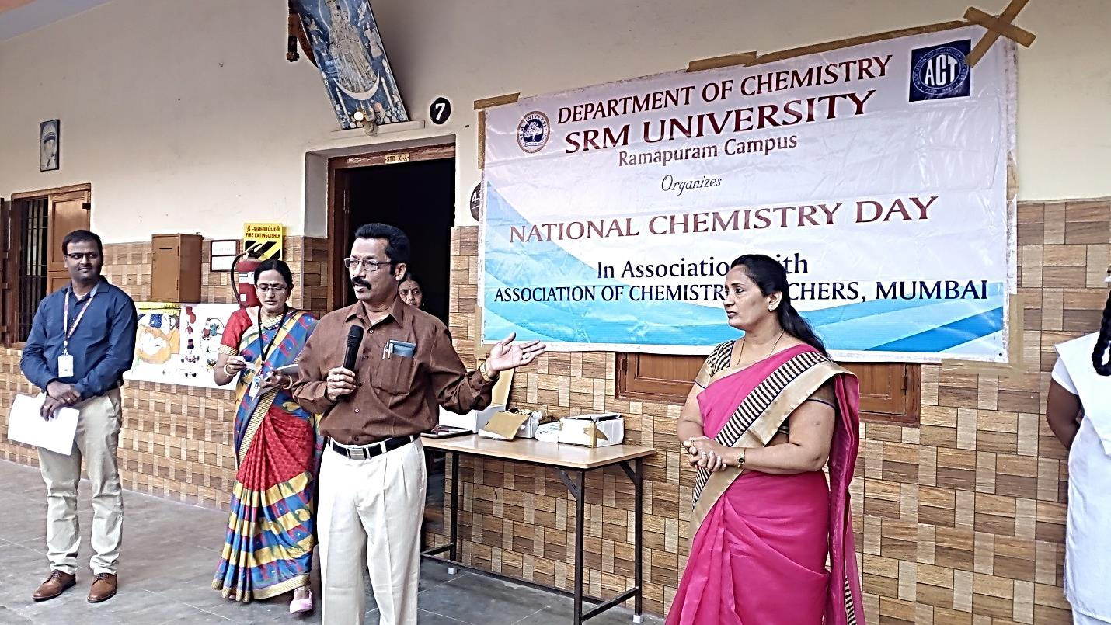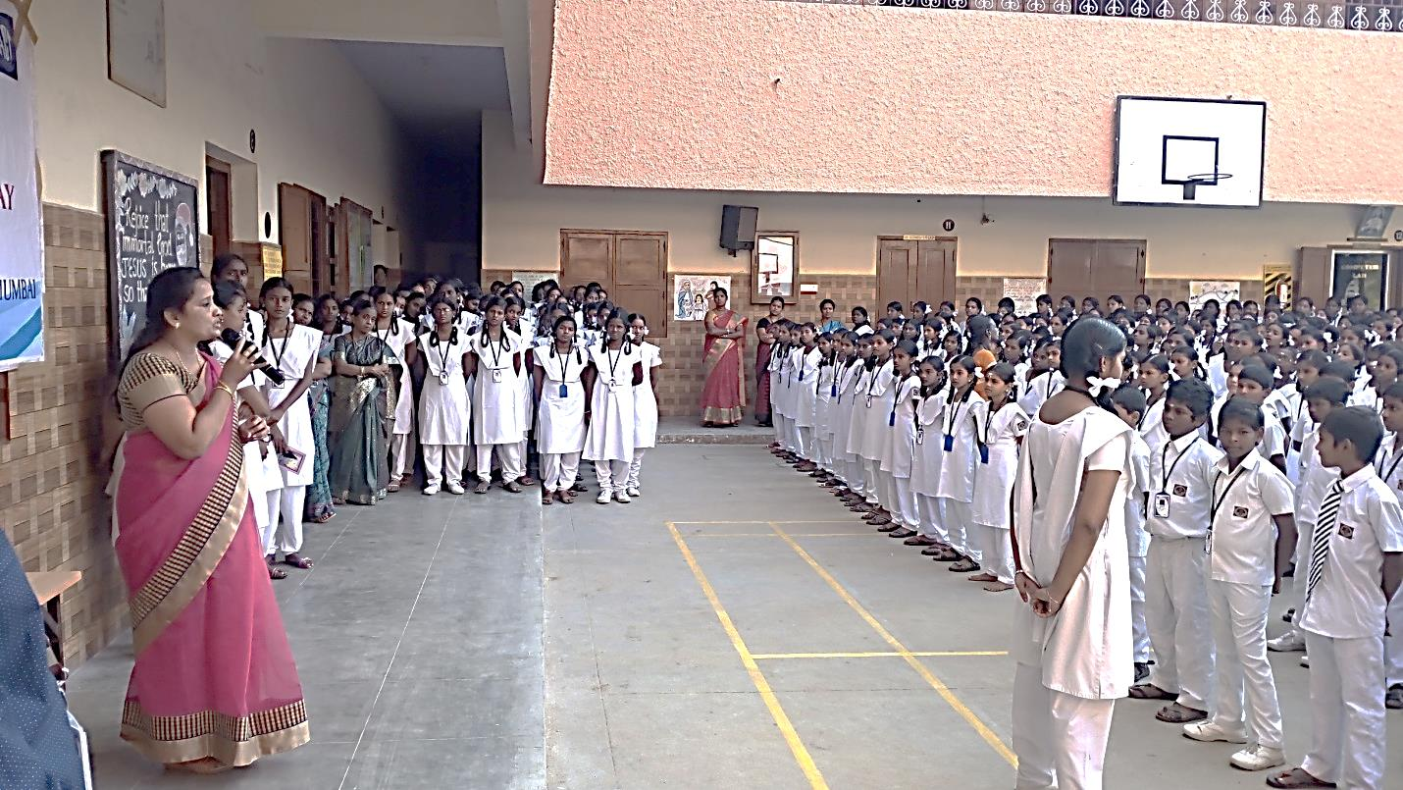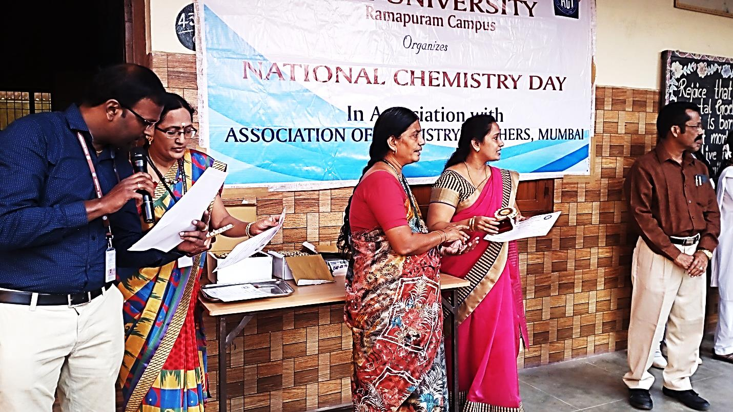
--------------------------------------------------------------------------------------------------------------------
This is how Samsung's foldable phone may look like
A recent patent application shows that Samsung has ambitious ideas for future phone-design experimentation, although the South Korean manufacturer may have second thoughts about bendy phones after recent battery explosions and recalls. In April, Samsung was reported to have filed a patent with the Korean Intellectual Property Office for a foldable smartphone. The application was picked up by Dutch website Galaxy Club.
The document shows a narrow Samsung device with a screen that bends and folds like an old-school flip phone handset. The device is described as something that can be “folded or unfolded semi automatically.” The patent also referred to a “secondary” display, which is supposed to activate when you fold the device, according to International Business Times UK.
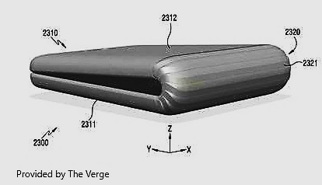
The patent definitely adds weight to the rumor, reported earlier this year by Bloomberg, that the company has plans to ship smartphones and tablets with bendable OLED screens. The trend of bendable screen has emerged in line with the bendable “wrist phone” trend. In June, Lenovo displayed a prototype and demo of its own bendable phone and tablet in its Tech World 2016 event.
Via: Android Police Source: Galaxy Club
--------------------------------------------------------------------------------------------------------------------------
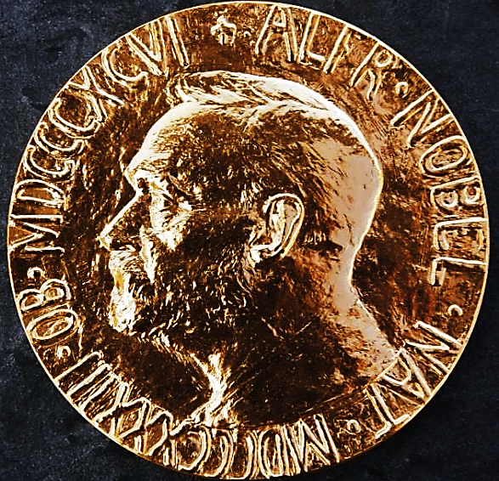 Nobel Prize in Chemistry 2016
On October 5, the Nobel Prize in Chemistry 2016 was jointly awarded to Jean-Pierre Sauvage, Sir J. Fraser Stoddart and Bernard L. Feringa for their design and production of molecular machines.
"Their contributions to the development of molecular machines based on fundamental principles of co-ordination chemistry and hydrogen bonding is outstanding and demonstrates how the combination of structural ideas and imaginative synthetic chemistry can be so powerful when combined effectively." Michael Mingos, University of Oxford, Series Editor of Structure and Bonding.
These molecules consist of parts which can move relative to each other without being covalently linked. Freer mechanical bonds are used to build such interlocked molecular architectures for controlled motion. Each of the awardees has made major contributions to the development of this growing field.
The first breakthrough in this field was contributed by Jean-Pierre Sauvage and co-workers in 1983 who reported the straightforward synthesis of catenanes and rotaxanes. While the concept of mechanically-interlocked molecular architectures had been discussed in the preceding years this was the first time that such structures could be easily synthesized and marked the first step in the development of molecular machinery. The Springer book “Molecular Machines and Motors” edited by the Nobel Laureate is published in the Series Structure and Bonding and provides an insight to this topic. Series Editor (Structure and Bonding) Michael Mingos shared his thoughts on the new Nobel Laureates, ‘their contributions to the development of molecular machines based on fundamental principles of co-ordination chemistry and hydrogen bonding is outstanding and demonstrates how the combination of structural ideas and imaginative synthetic chemistry can be so powerful when combined effectively.’
In 1991 a huge advance in the field was contributed by the second awardee Sir J. Fraser Stoddart who reported the first molecular shuttle by demonstrating that a rotaxane ring is able move along a molecular axle. He is Editor-in-Chief of the SpringerOpen journal Applied Nanoscience, which is dedicated to cutting-edge research in this area of nanotechnology. These outstanding contributions from Jean-Pierre Sauvage and J. Fraser Stoddart provided the foundations to molecular machines.
Building on these developments in 1999 Bernard (Ben) L. Feringa reported the first molecular motor performing light-driven unidirectional rotation. This system was utilized to generate molecular motors performing tasks; for example a rotor blade spinning continually in the same direction or a nanocar with four motor components moves on a surface. This discovery marks a major advance in the development of molecular machinery and though there is still some way to go it seems that molecular robots will play an important role in science and in future applications like sensors, energy and data storage.
--------------------------------------------------------------------------------------------------------------------------
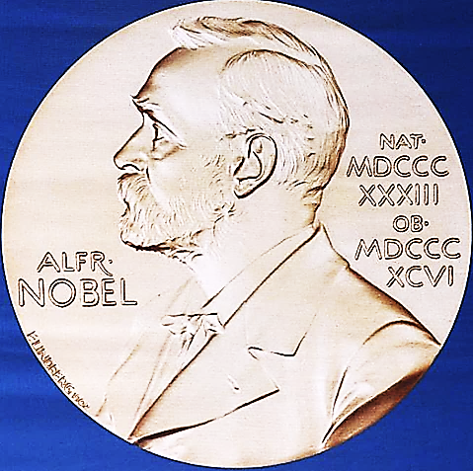 On which day is the Nobel Prize award ceremony held each year?
Alfred Nobel died on Dec. 10, 1896 at the age of 63 in Sanremo, Italy after suffering a stroke. Therefore, Noble Prize award ceremony is held on December, 20 each year.

Who was the first person to receive two Nobel Prizes?
Marie Curie received the Nobel Prize in Physics in 1903 and in Chemistry in 1911.
--------------------------------------------------------------------------------------------------------------------------

Global R&D trends challenge traditional science powerhouses
BY REBECCA TRAGER27 JUNE 2016
The US remains the single largest funder of research and development (R&D) in the world, but emerging trends show the global science funding landscape is becoming more diverse, according to new analysis by the American Association for the Advancement of Science (AAAS). In terms of overall R&D spending, the data show that among the 34 members of the Organization for Economic Co-operation and Development (OECD), total R&D spending rose 2.1% in real terms from 2013 to reach $1.1 trillion (£750 billion) in 2014.

As a percentage of global GDP, OECD R&D rose from 2% in 1995 to 2.1% in 2004, and then grew more rapidly to reach 2.4% in 2014. However, R&D funded by governments in the advanced OECD economies has declined or flattened since the global financial crisis. The Obama administration fell just short of the president’s goal to increase US spending on R&D to more than 3% of GDP. At the same time, the new AAAS analysis by senior project coordinator David Parkes concludes that global R&D investment is shifting to east Asian nations. He notes that South Korea doubled its R&D spending as a share of GDP over the past 20 years to reach 4.29% in 2014.
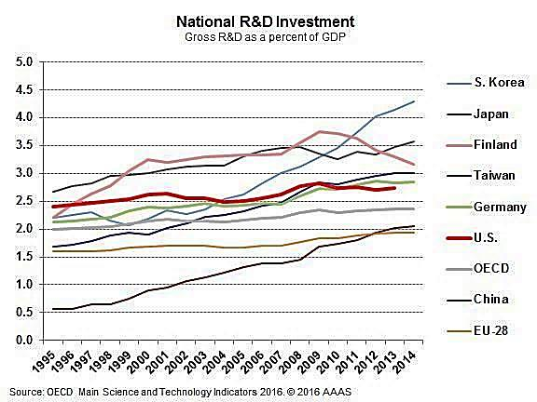
Nanorockets now available with breaks and a steering wheel
Story Source: Materials provided by Radboud University

Tiny machines like nanorockets are ideal candidates for drug delivery in the human body. Chemists at Radboud University now demonstrate the first complete movement regulation of a nanorocket by providing temperature responsive barkes. An interesting feature for practical applications since temperature sensitivity enablles the rocket to stop in diseased tissues where temperatures are higher. Nature Chemistry publishes their results on December 12, 2016.

The soft nanosystems that the bio-organic chemists at Radboud University work with self assemble, which means that they spontaneously form functional units. This allows the nanorockets to change shape, making them ideal candidates for containing cargo like medicine. “Our biggest challenge is to provide our nanorockets with various functionalities’, says Daniela Wilson, head of Radboud University’s Bio-organic chemistry department and Nanomedicine theme leader. ‘We now demonstrate the first molecularly built brake system, enabling the rockets to start and stop at desired locations’.

Temperature response brakes: The breaks consist of brushes made of polymers – long chains of responsive units – that grow onto the surface of the nanorockets. These brushes swell or collapse in response to the environmental temperature and in this way regulate fuel access to the rocket. In this case H₂O₂. Their sensitivity is high, as is shown by the fact that the brushes immediately collapse at a temperature of 35ºC or higher, making the machine to stop. ‘This all happens without affecting the catalytic activity or the shape of the nanorocket’, expalins Wilson. ‘Therefore, nanorockets equipped with this valve system are able to move with great efficiency in water, evan at low concentrations of fuel’.

Magnetic field acts as steering wheel: In another publication in Advanced Materials, Wilson and colleagues show how low magnetic fields can act as a steering wheel for the nanorockets. By growing magnetic metallic nickel into the core of the rocket, magnetic field can be used to guide and steer the rockets into desired directions.

But, there always room for improvement. Wilson: ‘What would be even more interesting than temperature responsive brakes, is a system that responds to light. This would allow us to start or stop a nanorocket by shining a laser light on it. Furthermore, even though our nanorockets are not toxic to living cells, they are not completely biodegradable yet. And of course that is one of the prerequisites for their use as medicine carriers in the bdy. These are only some examples of the next challenges for our group!’

Journal Reference
- Yingfeng Tu, Fei Peng, Xiaofeng Sui, Yongiun Men, Paul B. White, jan C. M. van Hest, Daniela A. Wilson. “Self – propelled supramolecular nanomotors with temperature-responsive speed regulation. Nature Chemistry, 2016, DOI: 10.1038/nchem.2674
--------------------------------------------------------------------------------------------------------------------------
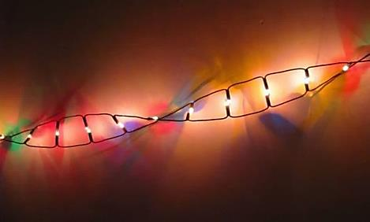 The length of you DNA extends to Pluto, and back...6 times. If you could unravel your body’s entire DNA and lay it out end-to-end, it would reach 34 billion miles. The distance from Earth to Pluto is only 2.66 billion miles. An exploded star: a teaspoon of it weighs more than Mt. Everest.
A neutron star forms when a giant star finally explodes. These stars are incredibly dense and spin around 600 times in one minute. If one teaspoon of it weighs the same as Mount Everest, how dense is the whole star? The mind boggles.
------------------------------------------------------------------------------------
Forthcoming Activities:
- National Seminar on “Recent Advances in Chemical and Environmental Research (RACE-2017),” Department of Chemistry, Annamalai University, January 20-21, 2017.
- National Conference on “Recent Trends in Chemistry (RTC-2017)” at Sikkim Manipal Institute of Technology (SMIT), Rangpo, Sikkim, February 17-18, 2017 (Convener: Prof. (Dr.) Sangeeta Jha, Head, Dept. of Chemistry, SMIT, Sikkim).
- National Seminar on “Recent Advances in Bio-inorganic and Medicinal Chemistry,” February 15th, 2017 (Convener: Dr. N. Raman, Department of Chemistry, VHNSN College (Autonomous), Virudhunagar, Tamil Nadu).
- National Science Day Celebrations, February 25th, 2017. SRM University, Ramapuram Campus, Chennai. (Convener: Prof. (Dr.) Helen Kavitha, Head, Dept. of Chemistry, SRM University).
- National Science Day Celebrations, February 27-28, 2017. Students from 50 schools are participating. (Convener: Dr. Mannam Krishnamurthy, Varsity Education Management Ltd., Hyderabad).
- 4th World Congress on Mass Spectrometry, London, U. K., June 19-21, 2017.
- 2nd International Conference and Exhibition on Materials Chemistry, Berlin, Germany, July 13-14, 2017.
---------------------------------------------------------------------------------------------------------------------

Coordinates of more than 23,000 atoms in technologically important material mapped
Date: February 1, 2017
Source: University of California - Los Angeles
Physicists have mapped the coordinates of more than 23,000 individual atoms in a tiny iron-platinum nanoparticle to reveal the material's innate defects. These results demonstrate that the positions of tens of thousands of atoms can be precisely identified and then fed into quantum mechanics calculations to correlate imperfections and defects with material properties at the single-atom level.
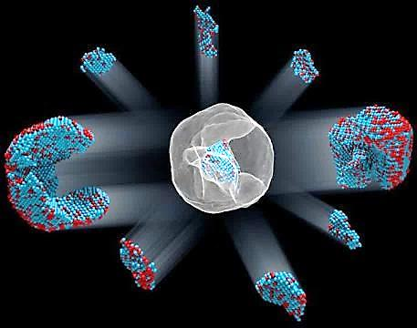 Identification of the 3-D coordinates of 6,569 iron and 16,627 platinum atoms in an iron-platinum nanoparticle to correlate 3-D atomic arrangements with material properties at the single-atom level.
Credit: Courtesy of Colin Ophus and Florian Nickel

In the world of the very tiny, perfection is rare: virtually all materials have defects on the atomic level. These imperfections -- missing atoms, atoms of one type swapped for another, and misaligned atoms -- can uniquely determine a material's properties and function. Now, UCLA physicists and collaborators have mapped the coordinates of more than 23,000 individual atoms in a tiny iron-platinum nanoparticle to reveal the material's defects.
Reference:
Yongsoo Yang, Chien-Chun Chen, M. C. Scott, Colin Ophus, Rui Xu, Alan Pryor, Li Wu, Fan Sun, Wolfgang Theis, Jihan Zhou, Markus Eisenbach, Paul R. C. Kent, Renat F. Sabirianov, Hao Zeng, Peter Ercius, Jianwei Miao. Deciphering chemical order-disorder and material properties at the single-atom level. Nature, 2017; 542 (7639): 75 DOI: 10.1038/nature
===========================================================================
NEWS
Science research
Magnetic droplets stamp out protein patterns
Droplets rolling across a lotus leaf spark device assembly idea
©Thomas Vogel/Stock
Scientists from China and Portugal have drawn inspiration from lotus leaves to devise a technique for arranging a wide range of materials, including cells, proteins and quantum dots, on a surface. Their method could be useful for making biomedical devices.
The team, led by Wenlong Song from Jilin University, noticed how water droplets strip dust from lotus leaves when they roll across their super hydrophobic surface. ‘We supposed that if this could be managed by a suitable driving force, it would allow the transfer of water-soluble materials onto the surface,’ explains Wenlong.
His team has now done just that. They put droplets containing a mixture of the material to be deposited, in this case protein, and chitosan hydrogel spheres onto a super hydrophobic surface. Iron oxide nanoparticles embedded into the hydrogel spheres meant a magnet placed on the other side of the surface could pull the droplets against the surface, stamping it with the protein in the droplet, much like a ballpoint pen. The researchers can move the magnet to draw shapes or reduce its power to move the droplet without writing on the surface. They could also change the sphere’s size to allow them to draw thicker or thinner lines.
‘Unlike other patterning methods, this could be performed in any laboratory and almost all water-soluble materials can be deposited on a super hydrophobic surface,’ says Wenlong.
Raechelle D’Sa, an expert in biomedical engineering from the University Of Liverpool, UK, describes the idea as an elegant biomimetic approach. She highlights the technique’s versatility: ‘Surfaces with patterns of wettability rather than physical barriers can lead to advances in existing or new technologies, such as cell patterning, bioassays, high throughput screening and tissue engineering.’
To extend their method beyond water-soluble materials, the team is investigating ways to write oil-based materials onto super amphiphobic surfaces or even super hydrophilic surfaces under water.
Charlie Quigg

References
J Wang et al, Biomater. Sci., 2017, DOI: 10.1039/c6bm00867d
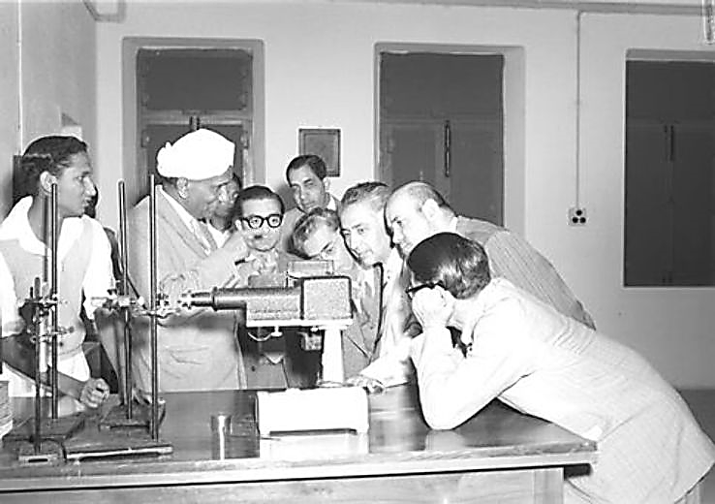
Sir C. V. Raman in the lanoratory with students
==================================================================
Editorial Board:
Dr. M. R. R. Prasad Dr. K. Sidhakarbabu
Dr. Subhash P. Singh Dr. P. V. S. Machiraju
Dr. Altaf Pandith Dr. (Mrs.) Helen Kavitha
Dr. D. C. Deka

